**Your Free Downloadable**

**How to Master Speed Dating:**

**A Guide for Healthy-Minded People**

**looking for Healthy Relationships.**

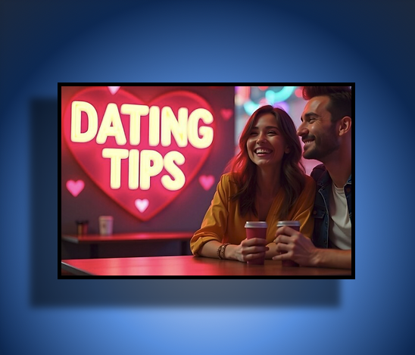

**By Casey Bruton**

Introduction 3

Chapter 1: What Is Speed Dating? 3

Chapter 2: Preparing for Your First Speed Dating Event 3

Chapter 3: Creating Authentic Connections During the Event 4

Chapter 4: Fun Additions to Your Speed Dating Experience 5

Chapter 5: Reflecting and Following Up 5

Chapter 6: Overcoming Common Concerns 6

Chapter 7: Long-Term Success in Building Healthy Connections 6

Conclusion 6

# Introduction

Speed dating is an exciting way to meet new people!! But sometimes, for those focused on healthy relationships and authentic connections, it can feel a bit intimidating.

This guide is here to help you navigate your speed dating experience with confidence and genuine intent, fostering meaningful interactions.

Whether you’re seeking a romantic connection or simply want to meet like-minded individuals, speed dating can be a fun, empowering, and rewarding experience with the right mindset and preparation.

# Chapter 1: What Is Speed Dating?

**The Basics**

Speed dating is a structured event where participants engage in brief conversations with multiple people. Typically, each interaction lasts 3–5 minutes before you move on to the next person. At the end, participants indicate who they’d like to meet again, and mutual matches are connected by the organisers.

**Why Speed Dating Works for Healthy-Minded People**

* **Genuine Connections:** The absence of prolonged digital interactions encourages authenticity.
* **Shared Intentions:** Participants are typically seeking meaningful connections.
* **Organised Structure:** Time limits and guidelines make conversations purposeful and efficient.

# Chapter 2: Preparing for Your First Speed Dating Event

**Mindset Matters**

* **Embrace Curiosity:** Treat the event as an opportunity to meet interesting people rather than focusing solely on finding “the one.”
* **Leave Expectations at the Door:** Every interaction holds value, whether it leads to a date, a friendship, or just a fun memory.

**Practical Preparation**

* **Dress for Confidence:** Choose an outfit that reflects your personality and makes you feel great.
* **Practice Your Introduction:** Have a simple, engaging way to introduce yourself. For example: “Hi, I’m Casey. I’m passionate about painting and love weekend hiking trips. How about you?”
* **Prepare Icebreakers:** Use open-ended, light questions like:
  + “What’s the most exciting thing you’ve done this year?”
  + “What’s a hobby you’re really passionate about?”

# Chapter 3: Creating Authentic Connections During the Event

**Making a Great First Impression**

* **Smile Warmly:** A friendly smile sets a positive tone.
* **Maintain Eye Contact:** It conveys attentiveness and interest.
* **Focus on Positivity:** Steer the conversation toward uplifting topics.

**Building Healthy Conversations**

**Do:**

* Ask meaningful questions about their interests or values.
* Share light personal anecdotes.
* Offer genuine compliments when appropriate.

**Don’t:**

* Dwell on past relationships.
* Dominate the conversation.
* Bring up controversial topics too soon.

**Navigating Health and Wellness or other Lifestyle Topics**

If topics come up naturally, respond with confidence:

* “I don’t drink /much, but I don’t mind if you do”
* ”I prioritise health and well-being, but I don’t need to date a gym junkie”

# Chapter 4: Fun Additions to Your Speed Dating Experience

**The Bachelor/Bachelorette Flower Giveaway**

At the end of the event, each participant can anonymously give a flower token to someone who made a lasting impression. The organisers will distribute these tokens, letting recipients know they’ve caught someone’s attention. It’s a playful, low-pressure way to express admiration.

**Interactive Icebreaker Games**

* **Speed Compliments:** Give your date a compliment based on your first impression.
* **Guess the Fact:** Participants write a fun fact about themselves for their dates to guess.
* **Speed Dating Bingo:** Use a bingo card with traits or experiences to find matches during conversations.

# Chapter 5: Reflecting and Following Up

**Reflect on the Experience**

* **Celebrate Participation:** Attending an event like this is an achievement.
* **Assess Matches:** Think about who you connected with and why.

**Post-Event Tips**

If you like someone, follow up promptly. Keep messages light and friendly:

* “Hi [Name], it was great meeting you at the event! Would you like to grab a bite together after the event or a coffee some other time?”

# Chapter 6: Overcoming Common Concerns

* **“What if I don’t find a match?”**  
  Not every event leads to a connection, and that’s okay. View it as practice for future interactions.
* **“What if I’m nervous?”**  
  Remind yourself that everyone is there for the same reason. Focus on enjoying the moment.
* **“What if I feel awkward about discussing my lifestyle?”**  
  Your choices, whether about health, sobriety, or values, are part of what makes you unique. Share them with pride.

# Chapter 7: Long-Term Success in Building Healthy Connections

* **Stay Open-Minded:** True connections often come from unexpected interactions.
* **Build a Support Network:** Connect with others who value healthy, authentic relationships.
* **Keep Growing:** Focus on self-improvement, hobbies, and nurturing other friendships alongside dating.

# Conclusion

Speed dating offers a powerful opportunity to create meaningful connections when approached with authenticity and an open heart. By preparing thoughtfully, embracing your values, and engaging genuinely, you’ll not only enjoy the experience but also foster connections that align with your desire for a healthy relationship.

Remember, this journey isn’t just about finding someone—it’s about growing, learning, and having fun along the way. So go on, connect, and most importantly laugh and have fun!!!

YOU GOT THIS!!!!